Join us for

Parenting Partners
Family Workshop

Bully Busters: Normal Conflict vs. Bullying

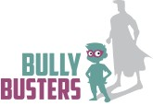
Tuesday, March 5, 2019 @
Edison Elementary School
5288 Karen Isle Dr. Willoughby, OH 44094
6:00-7:00p.m. (KG-5th Grade Youth and Adult
Workshops)
7:00-7:20 Family Dinner

Free Raffle
Free Dinner
Spaces Limited!
For more info: Angela Flowers Email: acflowers32@gmail.com
216-394-3012 or register online at www.makingadifferenceconsulting.com/Events

