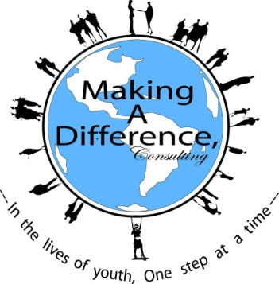
Making A Difference consulting Present:

2018 Student Application

Student Name: _______________________________________________________

Address:____________________________________________________________

City:_________________________ State: OH Zip:__________________________

Home Phone:_________________________Cell Phone:______________________

Age:___________ Date of Birth:________Last 4 Digits of SSN(Required)_________

School:_________________________________________Grade:_______________

Parent/Guardian Information:
Parent/ Guardian Name:________________________________________________

Address:____________________________________________________________

City:_________________________________ State: OH Zip:_________________

Home Phone:__________________E-Mail:________________________________

Person to Contact in Case of Emergency:
Name:_____________________________ Relation:_________________________

Address:____________________________________________________________
City:________________________________ State: OH Zip:_________________
Home Phone:__________________________ E-Mail:________________________

Making A Difference Consulting Present:

1.How would you describe your child’s basic skill level?______Weak______Average____Above average

2.Please list any known health problems (such as allergies, diabetes, heart trouble, epilepsy, or asthma, etc.) that we should be aware of__________________________________________________________

3. Please list any physical activities that your child should not participate in________________________
_____________________________________________________________________________________

4. Please list any food that your child should not eat____________________________________________
______________________________________________________________________________________

5. Please list any religious restrictions regarding what can be done for your child in emergencies/health care situations______________________________________________________________________________

6. Does your child have any invisible disabilities such as dyslexia? If yes, please explain._______________
__________________________________________________________________________________________________________________________________________________________________________________________________________________________________________________________________

7. Has your child ever been diagnosed or treated for a mental health disorder (i.e., depression, suicide, anorexia, etc.)? If so please explain._________________________________________________________
__________________________________________________________________________________________________________________________________________________________________________________________________________________________________________________________________

8. Has your child been suspended from school for aggressive behavior within the last school year? If so please explain__________________________________________________________________________
____________________________________________________________________________________________________________________________________________________________________________

9. Do you have any concerns about your child (i.e., low self-esteem, lack of motivation, etc.) If so please
explain.__________________________________________________________________________________________________________________________________________________________________________________________________________________________________________________________________________________________________________________________________________________

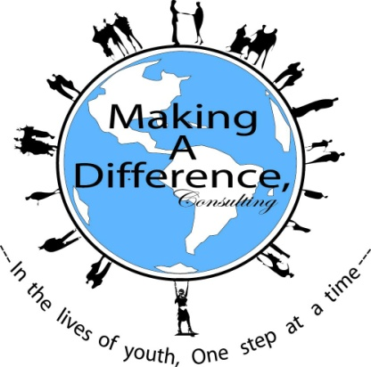

Making A Difference (MAD) Student Participation and Media Release Form

(For Students Under 18 Years Old)

Student Name:____________________________ Date of Birth:_______/_________/_______

Program Location: Euclid Central Middle School Program Coordinator: Angela C. Flowers

Program Period: June 11-June 28th (Mon-Thurs (9:00am-1:00pm)

The Student and Parent/Guardian hereby agree with Making A Difference (MAD) and the program sponsor as follows:

- The Student’s participation in the program, and all future MAD programs/events, is voluntary and the Student assumes all risks ad responsibilities concerning participation, including all activities the Student participates in, including but not limited to support group, field trips, evening, and/or physical recreation activities. The Parent/Guardian understands that there may be some risk of injury to the Student in these activities, but still desires that the Student participate.

- The Student and Parent/Guardian consent to allow MAD, its employees and agents to render medical treatment to the student if such treatment should be necessary during the course of the program, and all future MAD programs/events, including but not limited to support group, field trips, evening, and/or physical recreation activities. The Parent/Guardian is solely responsible for the cost of such treatment for the Student. It is understood that any agent taking action hereunder shall notify the Parent/Guardian of the same as soon as possible and that MAD should not delay obtaining any necessary medical treatment while seeking to notify the Parent/ Guardian. The Student and Parent/ Guardian authorize all physicians and other medical care providers, including hospitals, to provide medical care to the Student in accordance with the direction of MAD, its employees and agents.

- In consideration of the Student’s acceptance into and participation in the program, and all future MAD programs/events, the Student and the Parent/Guardian hereby agree to indemnify, hold harmless and release MAD, its officers, employees, volunteers, and agents from liability resulting from any illness, injury, damage to property, or other consequences directly or indirectly related to the Student’s participation in the program and all future MAD programs and events.

- The Student agrees to abide by all appropriate statutory laws and all rules and policies of MAD and/or the program sponsor. Failure to abide by the foregoing may result in termination of the Student’s ability to continue in the program, and all future MAD programs/events.

- Parent/Guardian agrees that should the Student choose to end participation in the and MAD program or misses more than 3 consecutive classes, the program will be non-refundable.

- I am the parent/legal guardian of the child named above, who is under the age of 18. I hereby provide permission to and MAD to include certain personal information about my daughter/granddaughter/ward in connection with support of and MAD programs/events including publication in: promotional materials, press releases, newsletters, web site contents, and in all media now known or hereinafter devised in perpetuity. I release MAD and it’s agents and employees from any claims of infringement, invasion of privacy, defamation or misappropriation arising from the use of the information provided by me in the permitted manner.

Disclosure: Some of the topics discussed during the camp may elicit strong emotions from participants. We will discuss a range of topics in various media forms (i.e., music, video, print). Some material may contain strong language. Professional counselors and therapists are available if such feelings are produced at any time.

Signature of Student:________________________________ Date: ______/________/________

____________________________________
Print Name

Signature of Parent/Guardian:__________________________ Date:_______/______/________

____________________________________
Print Name

